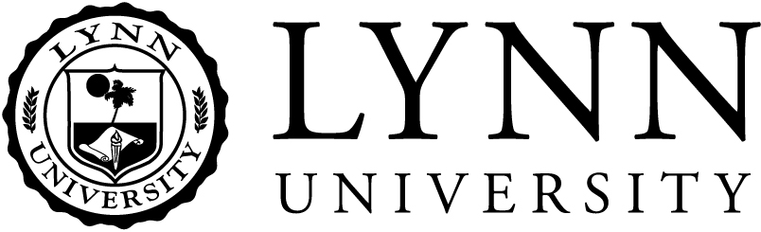
NONBINDING LETTER OF INTENT

Because of my special regard for Lynn University, I have provided in my estate
plan for the university to receive a gift of approximately _____________. Both the university and I recognize that this information is provided as an accommodation to Lynn and that I hereafter may change or eliminate the provision without incurring liability and without notifying the university.
By signing this Nonbinding Letter of Intent, I reaffirm my faith in Lynn University.
Special instructions to Lynn University for the use of my gift:
______________________________________________________________________________
______________________________________________________________________________
_______________________ __________________________________________
Date Signature of Donor

Gratefully acknowledged for
Lynn University

_______________________ By_______________________________________
Date
3601 North Military Trail | Boca Raton, FL 33431-5507 | 561-237-7745 | give.lynn.edu

